Top 10 Predictions for the Future

1. Read the texts about the top 10 predictions for the future by Danny Burke. Which predictions
do you think will most likely to happen in 2025?
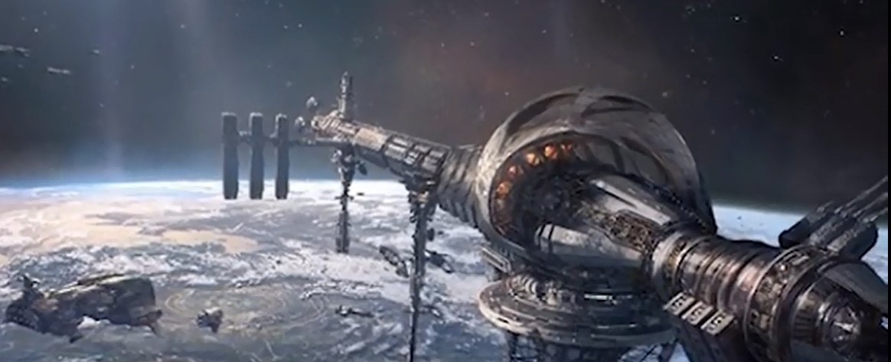
NUMBER 10
Whether number 10 and we're going to talk about space elevators. Some scientists think that the future of getting into space might not be by usingtraditional rockets and tons of fuel, but by simply taking an elevator up there. This will involve a machine crawling up a huge and almost unimaginable strong cable, and it was no longer under the influence of us gravity. For many, itspure science fiction but for others, such as the lift port group developing thespace elevator is actually their day job. They believe recent advances in materials, such as nanotubes. Mean that oneday be possible to build a structure. That's strong enough, flexible enough and light enough to allow machines to crawl out beyond theatmosphere and carry everything for cheap from cargo to tourists without asingle rocket in sight. Ok guys, it might sound a little bit out there, but hey they used to say thatlanding on the moon sounds crazy, and as my grandmother says anything is possible there.


NUMBER 9
But for now we're moving on to number 9 and let's talk about weather control. Ever since the first prey or rain dance humans have been trying tocontrol the weather to suit our needs. California has been using techniques, such as cloud seeding to stimulateclouds with particle to try and make it rain for more than 50 years. In 2008 the Chinese government flew 1100 rockets into the sky to release chemicals thatwould stop clouds from raining on the opening ceremony for the Beijing Olympics. This has led many individuals groups and countries around the world to conducttheir own research in the belief that humans will one day be able to masterthe science of weather modern modification. The benefits of this will range from little things like stopping arainy day from brewing, even to be able to prevent hurricanes and storms before they even start at all. Personally, I think someone's already been tinkering with the weather in England, because, come on, it can't rain that much just to stop, come on.

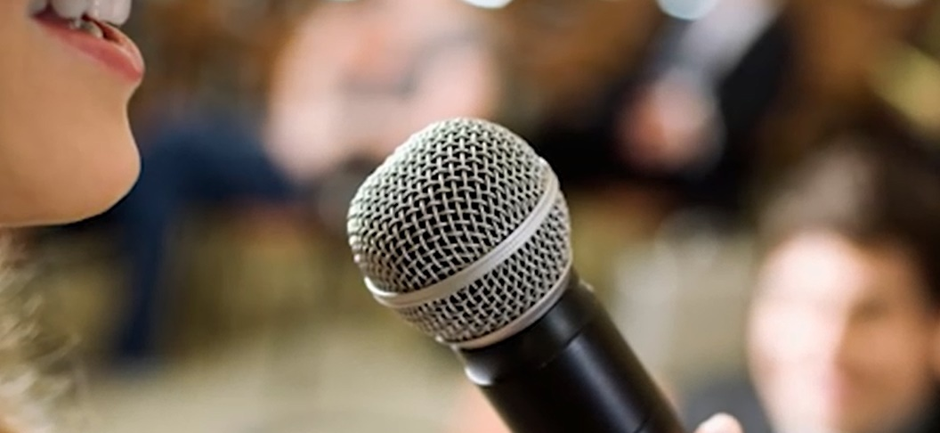
NUMBER 8
At number 8, linguists predict that by the year 2150 many languages being spoken right. This second will be completely dead. Today there are over 7,000 different languages, but 100 years from now 90% of these will be gone, as a society becomes more globalized andinterconnected. Dominant languages will appear, where once there are manydifferent tongues. These are likely to be English, Spanish and Chinese Mandarin. Other languages, such as Arabic and Hindi and even French are expected to see a surge in nativespeakers. Thanks to a booming population growth in a country where they are spoken well. Asfor the English, it won't be the number one most spoken language in the world, but it will continue to grow, as non-native speakers use it as a common tongue to communicatewith each other. I pretty happy to hear that, as I don't know any Chinese, and I forgotten most of my high school French.
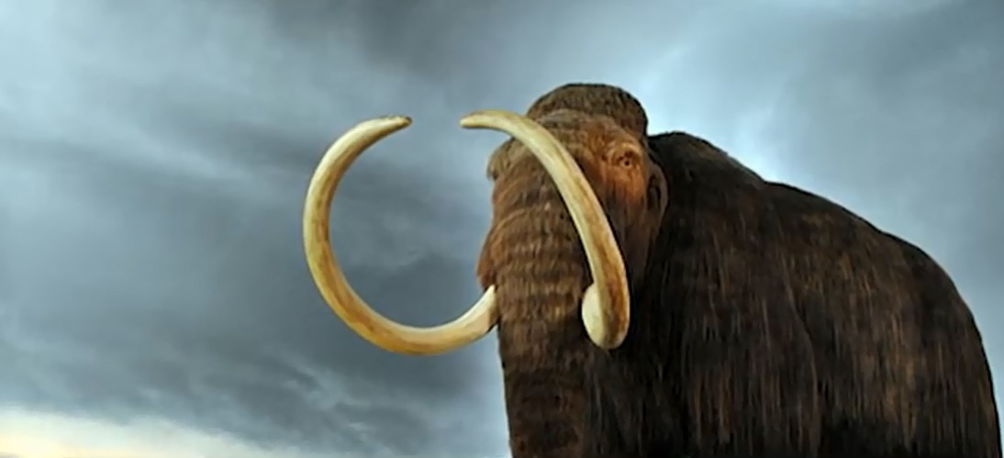
NUMBER 7
At number 7 now it's being predicted thatthe future will see mass extinctions of animals like nothing we've seen before. A scientific study suggested that the earth is losing 11,000 – 58,000 species to extinction every single year, and points the finger of blame a humanpollution, deforestation and expanding habitats. Some even go so far as to say that we may be entering a new mass extinction torival the devastating wounds of the past. It’s thought that the current trend continues. We could see extinctions atthe same rate as the one that killed the dinosaurs in just 250 years from now. And that one was called by a massive asteroid. That was 300 milesacross. So, yeah, humans can be pretty scary.


NUMBER 6
On to number 6technology experts predictthe future we'll seeinternet connection for every human alive. Right now, there's 7.4 billion people on the planet, but only 3.3 billion of those including you, watchingthis have any sort of access to the Internet. It won't stay this way forever, though. Companies such as Facebook, Google andSpaceX have been launching their own initiatives to connect everyone online for the first time in history. It has predicted by the year 2025 all eight billion people on planet earth will have access to the internet. So, if you're watching this, from the year 2025, I hope I got some ofthese right halfway through.

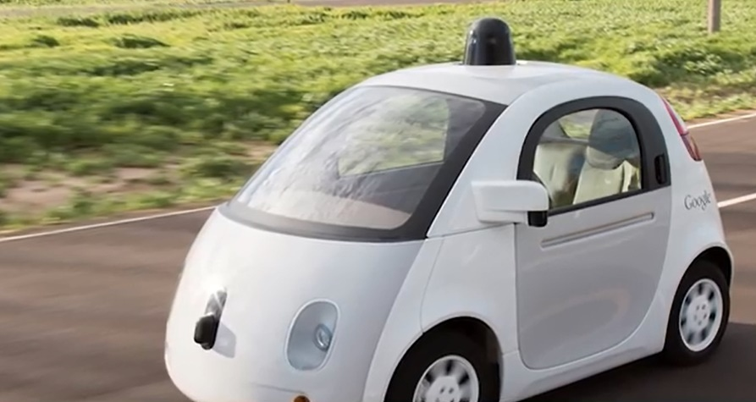
NUMBER 5
And our guys, at number 5 is predicted by some people thatdriverless cars will hit the market as soon as 2020 years later. In 2025, thedriverless car will be commonly used around the world, and 5 years after that in 2030 the average American Idol will spend 40% of their timein driverless cars. It stores a driver's car will become such a part of society. The government might even require it as a safety feature. If your car doesn't have an automated system, it will be seen as at best old-fashioned, and at worst a danger to you and other road users. If you guys areadults already, then you probably will be by 2030, so it could be you guys watching this right now that will be driving driverless cars or are not driving. Canyou call it driving? I know when you guys get one, let me know.


NUMBER 4
At number 4, human life expectancy has been growing for well over a hundred years now. And it's not expected to slowdown in the future. For every year that passes from now on the average Americanis expected to live three months longer. By 2050, the average person will beexpected to live - 88 years old. And by 2100 some people predict that mighteven reach 100 years old. Advancements in medicine, sanitation, diet and education are just some of thefactors that lead people to foresee a future where the old just keep gettingolder. I know guys, I'm not sure how I feel about this. Do you think that's kind ofawesome? Everyone's gonna be living for so longor there's something a little bit unnatural about it. Let me know in the comments below.

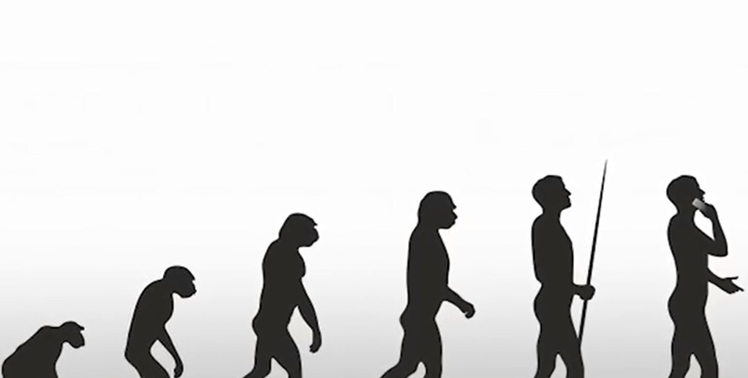
NUMBER 3
On the number 3, it's been predicted by the year 2100humansdon't be getting their energy the same way we do today. The vast majority of ourenergy will be obtained from renewable sources such as, wind or solar. The oldfossil fuels that we burn as the power of society in modern times will be replacedwith cleaner and cheaper sources. Who knew that insanely large burning ball of energy in the sky could be used to get all that energy. I did not see that onecoming.

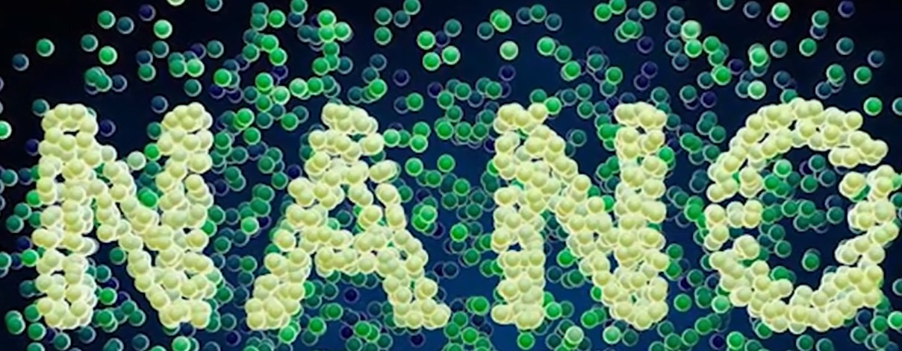
NUMBER 2
At number 2, nanotechnology is the future. It's the manipulation of matter on the Nano scale which is about 1 to 100nanometers. It's been the stuff of science fiction for a while now. The researchers areconfident that it will be an integral part of our society in the near future. Nano robots could be injected into the bloodstream of sick people to instantlycure any diseases, and some claim that once the technology is perfected everyvirus or disease including cancer will be easily cured. These tiny Nano are predicted to be using every part of our lives, such asmicroscopic cameras for security. So, aside from all that amazing stuff that was curing cancer, nanobots can also be put into your food to literally change into whatever else you want. Itsounds like a bright future fascinating.

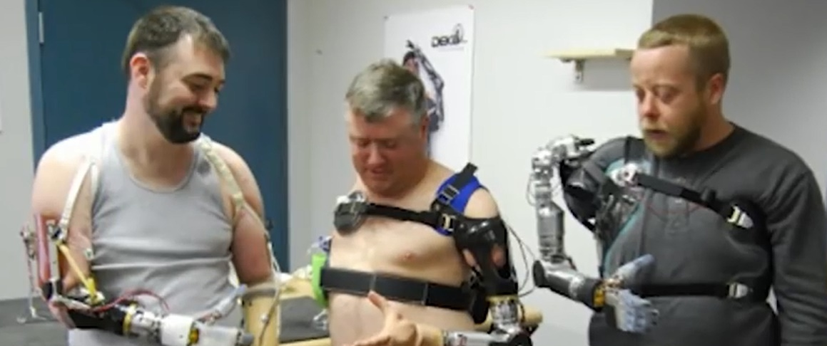
NUMBER 1
All right guys, coming in out number 1. The national intelligence council is a US government agency whose job is topeer into the future and try and spot global trends before they happen. One of their biggestproductions at the moment is humans entering what isbeing called the trans-human era. As we begin to use more prosthetics, implants and technology in our bodies. The NYC predicts that humans can and will becomeBionic in a very real sense of the word. New machine limbs will perform better than the ones people are born with blurring the lines between humans and machines. Brain implants will allow the brain to perform much much faster and super-strong. Excess curtains will become commonplace and soldiers. The trans-human era will bring humans and technology together. In a way that will make down that like superheroes to worse, and it'spredicted that this will start happening as early as 2030. Personally I can't lie I love the idea of the order to access any informationinstantly with my mind or being like super strong or super-fast. But at the same time, guys, with thatI mean we're losing a part of what makes us truly human. It could be a scary future. It could be a fascinating future, and it could be anything in between. It is anybody's guess.

Retrieved from https://www.youtube.com/watch?v=-c173R5-heI

2. Discuss the following questions with your classmates.

- Do you think the future will have an absolute change?
- How do you feel about changes?
- What are some the things that you feel comfortable changing? And what are some of the things that you don’t feel comfortable changing?
- How do you see the future?
- How do you face the future?

Note:
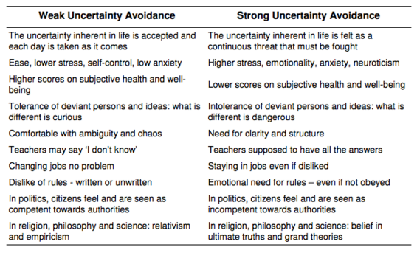
(Retrieved from http://www.wikiwand.com/en/Hofstede's_cultural_dimensions_theory)

